|  |  |
| --- | --- |
|  | **Al-Aqsa University** |
| **Faculty of Computers and Information Technology** |
| **Applied Information Technology Department** |

# GradTrack: A Smart Web Platform for Efficient Graduation Project Management

**A graduation project submitted in partial fulfillment of the requirements for the degree of Bachelor of Applied Information Technology**

**By**

|  |  |
| --- | --- |
| **Nada Raid Shaheen** | **Saja Islam Abu-Shoaib** |

**Supervisor**

**Mr. Mohammed Abu-Hayya**

**May,2025**

The copyright of this thesis belongs to the authors under the terms of the copyright Act 1987. Due acknowledgement shall always be made of the use of any material contained in, or derived from, this thesis.

© 2025, Nada Shaheen, Saja Abu Shoaib. All rights reserved.

# DECLARATION

I hereby declare that this project report is based on my original work except for citations and quotations which have been duly acknowledged. I also declare that it has not been previously and concurrently submitted for any other degree or award at University Al-Aqsa of Faculty of Computers and Information Technology or other institutions.

# APPROVAL FOR SUBMISSION

I certify that this project report entitled “GradTrack: A Smart Web Platform for Efficient Graduation Project Management” was prepared by NADA SHAHEEN and SAJA ABU-SHOAIB has met the required standard for submission in partial fulfilment of the requirements for the award of Bachelor of Applied information technology at University Al-Aqsa of Faculty of Computers and Information Technology.

# Dedication

I dedicate this project to my dear family, whose constant support and encouragement have been the foundation of my journey. To my parents, for their sacrifices and unwavering trust in me, even in the darkest of circumstances. To my friends and mentors, who have guided and supported me every step of the way. A special dedication goes to my project partner, Saja Abu Shaib, for her cooperation and dedication throughout this journey. I also dedicate this work to the martyrs and people of Gaza, who have demonstrated unparalleled resilience and courage. Your sacrifices inspire me to persevere.

# ACKNOWLEDGEMENTS

To my university, Al-Aqsa University, and my college, the College of Computers and Information Technology And my distinguished department is the Department of Applied Information Technology.

And I don't forget to dedicate this project to all the doctors Teaching assistants at the Faculty of Computers and Information Technology at Al-Aqsa University To all my teachers at all levels of education throughout my academic career. To all my loyal friends, whom I always find help and support in adversity and prosperity. To everyone who supported me and helped me and spared no effort to help me at any time to everyone who contributed to the achievement of this modest work, I dedicate this modest work. Asking God Almighty to guide us and to you all the best.

In addition, I would also like to express my gratitude to my loving parent who had helped and given me encouragement.

# GradTrack: A Smart Web Platform for Efficient Graduation Project Management

# ABSTRACT

GradTrack is a smart web-based platform developed to transform the management of graduation projects in academic institutions. It addresses persistent challenges such as inefficient communication, disorganized tracking, and lack of timely feedback by offering a centralized and structured system.

The platform empowers students to submit deliverables, monitor progress across all project phases, and communicate effectively with supervisors. Simultaneously, supervisors can evaluate submissions, provide structured feedback, and schedule meetings—all through an intuitive dashboard. By streamlining communication and task tracking, GradTrack enhances collaboration, ensures deadlines are met, and reduces the likelihood of errors or delays.

The system fosters transparency, academic discipline, and a smoother graduation process that supports academic excellence. Initially developed for Al-Aqsa University, GradTrack is scalable and can be adapted by other institutions seeking a reliable, modern solution for managing graduation projects efficiently.

Table of Contents

DECLARATION ii

APPROVAL FOR SUBMISSION iii

ACKNOWLEDGEMENTS v

ABSTRACT vi

TABLE OF CONTENTS Error! Bookmark not defined.

LIST OF TABLES ix

LIST OF FIGURES x

CHAPTER 1 11

1. INTRODUCTION 11
   1. Background 11
   2. Problem Statement 13
   3. Aim and Objectives 14
   4. Scope 14
   5. Significance of the Project/Research 15
   6. Organization of Thesis 15

CHAPTER 2 17

1. LITERATURE REVIEW 17
   1. Introduction 17
   2. Background 17
   3. Evolution of T-Shirt Design Platforms 21
   4. User Experience in T-Shirt Design 27
   5. Related Works 30
   6. Summary 34

CHAPTER 3 36

1. METHODOLOGY 36
   1. Introduction 36
   2. RAD Model 37
   3. Development Technology 40

CHAPTER 4 45

1. IMPLEMENTATION OF DESIGN 45
   1. Introduction 45
   2. Project Timeline 46
   3. User Requirements 46
   4. Sequence Diagram 49
   5. Proposed User Interface 50
   6. Application testing 53

CHAPTER 5 59

RESULTS AND DISCUSSION 59

* 1. Introduction 59
  2. Functional Assessment 59
  3. Usability Assessment 61
  4. Summary 62

CHAPTER 6 64

CONCLUSION AND RECOMMENDATION 64

* 1. Project Summary 64
  2. Achievement 64
  3. Future Work 65
  4. Summary 67

REFERENCES 68

# LIST OF TABLES

|  |  |  |
| --- | --- | --- |
| **TABLE** | **TITLE** | **PAGE** |
| 3.1  4.1  4.2  4.3  4.4  4.5  4.6 | Hardware specification Color Selection functionality  Template upload functionality Ask AI Functionality  Design toggle functionality  Design toggle functionality Template Download functionality | 44  53  54  55  56  57  58 |

# LIST OF FIGURES

|  |  |  |
| --- | --- | --- |
| **FIGURE** | **TITLE** | **PAGE** |
| 3.1  3.2  3.3  3.4  3.5  4.1  4.2  4.3  4.4  4.5  4.-6  4.7  4.8 | Rapid Application Development React.js  Tailwindcss OpenAI API Vite.JS Gantt chart  Use Case Diagram for DESIGNAI Platform Sequence Diagram for T-shirt Customization Process Main Interface of DESIGNAI Web Application  T-Shirt Designing Interface Color Selection Feature Template Upload Feature  Ask AI Feature | 38  41  42  43  44  47  48  49  50  51  52  52  53 |

# CHAPTER 1

**INTRODUCTION**

## Background

Graduation projects are a critical component of academic programs, shaping students' professional and research skills. However, managing these projects poses significant challenges for both students and supervisors. Traditional project management methods often lead to communication breakdowns, inefficient tracking of progress, and delays in receiving structured feedback. The lack of a centralized system results in scattered communications, missed deadlines, and difficulty in monitoring project stages.

To overcome these challenges, GradTrack introduces a smart web-based solution designed to optimize project workflows, enhance collaboration, and ensure seamless supervision throughout the project lifecycle. The platform integrates real-time tracking, document sharing, automated reminders, and scheduling meetings to enhance efficiency and transparency throughout the project lifecycle.

## Problem Statement

Many academic institutions struggle with managing graduation projects due to several key issues:

Ineffective tracking of project stages and deadlines.

* Lack of a centralized system for document storage and collaboration.
* Poor communication between students and supervisors.
* Limited visibility into project progress and feedback.
* Supervisors often struggle with managing multiple projects simultaneously due to the lack of a centralized tracking system.

These challenges often lead to frustration, delays and suboptimal academic performance. GradTrack aims to solve these issues by introducing a smart, web-based solution that enhances accessibility, organization, and accountability.

## Aim and Objectives

* + 1. **1.3.1 Aim**

The aim for the project develop a smart and centralized web-based system (GradTrack) that streamlines the management of graduation projects by enhancing communication, ensuring organized tracking, and enabling structured feedback between students and supervisors.

* A fully operational web platform with an intuitive user experience.
* Deadline reminders and stages tracking to enhance accountability.
* Secure and centralized document storage for streamlined access to project files.
* Enhanced communication tools, such as comments and replies and notification systems, to improve collaboration.
* Comprehensive analytics for project performance assessment.

## 1.3.2 Objectives

**General Objective**

To optimize the graduation project management process by improving communication, project tracking, and structured feedback mechanisms.

**Specific Objectives**

* Enhance Collaboration: Facilitating structured and direct communication between students and supervisors through seamless comments and replies and efficient feedback exchange.
* Improve Project Tracking: Enable students to monitor stages, see scheduled meetings, and submit deliverables on time.
* Centralized Documentation: Offer a secure, web-based repository for storing and sharing project files.
* Structured Feedback Mechanism: Ensure supervisors can provide timely and organized feedback for continuous improvement.

## Scope

The platform offers a comprehensive set of tools for tracking project progress, managing deadlines, submitting required documents, and facilitating communication. However, its effectiveness is contingent on several factors, including internet availability and user adaptation to t,,,,,he platform's features, which may necessitate an initial learning phase.

## Significance of the Project/Research

GradTrack is designed to revolutionize the graduation project experience by ensuring seamless collaboration, real-time tracking, and structured supervision. By replacing outdated manual processes with a smart, digital solution, GradTrack empowers both students and supervisors, ensuring that projects meet high academic standards while reducing administrative workload.

## Organization of Thesis

The organization of the thesis are as follow:

1. Chapter 1: Introduction

In this section will briefly discuss the background, problem statement, aim, objectives, scopes, and significance of this project.

1. Chapter 2: Literature Review

The literature review critically examines existing research relevant to AI in design, customization options in the fashion industry, user-friendly interfaces, and ethical considerations in AI applications. This chapter identifies gaps in the current knowledge and establishes the theoretical foundation for the research.

1. Chapter 3: Methodology

This section will go through the methodology used for developing this project, as well as the activities that will be conducted at each stage of the methodology applied. Moreover, this section will also focus on the software and hardware technologies of the project.

1. Chapter 4: Implementation of Design

This section will discuss the proposed use case diagram and sequence diagram of the system and explain the core function of this project. The proposed user interface will also discuss in this chapter.

1. Chapter 5: Conclusion

This section will conclude all the works and information from Chapters 1 to 4 in this project. The expected achievements in FYP 2 are also described in this chapter.

# CHAPTER 2

**LITERATURE REVIEW**

## Introduction

The literature review critically examines existing research relevant to AI in design, customization options in the fashion industry, user-friendly interfaces, and ethical considerations in AI applications. This chapter identifies gaps in the current knowledge and establishes the theoretical foundation for the research.

## Background

* + 1. **Historical Development of AI in Design**

AI was first introduced into the fashion business in the late 1990s and early 2000s. Simple jobs, mostly in demand forecasting and inventory management, were automated during this era. However, in comparison to the advanced technologies utilised today, these early systems were rather primitive (Shi Van Dyk Lewis, n.d.).

With the rise of e-commerce, the mid-2000s to early 2010s saw a substantial shift. Artificial Intelligence began to play a major part in improving the online buying experience. During this time, algorithms that used consumer data to customise shopping experiences were adopted. Fashion manufacturers made use of this data to gain a deeper understanding of consumer tastes, which resulted in more customised suggestions and effective supply chain management (Chakraborty et al., 2021).

The use of innovative machine learning techniques in the 2010s signalled a paradigm shift for AI in the fashion industry. With its ability to provide virtual try-on solutions and aid in trend prediction, image recognition technology has grown in popularity. These developments greatly improved the online purchasing experience by enabling shoppers to visually see clothing on themselves (Shirkhani et al., 2023).

The fashion industry saw AI play a more creative role from the mid-2010s to the early 2020s. AI is being used by designers to create new patterns and designs by fusing algorithmic precision with human ingenuity. Additionally, there was an increasing focus on sustainability at this time. Artificial Intelligence started to support sustainable practices by streamlining industrial procedures to reduce waste and enhance material efficiency (Choi et al., 2023).

The deep learning revolution hit the fashion industry as the 2020s got underway. Sophisticated AI applications, ranging from highly personalised recommendations to sophisticated trend forecasts, define this era. Through chatbots and virtual assistants, which provide individualised shopping assistance and better customer care, AI also increased client engagement (Joon & Chung, 2023).

It is anticipated that AI will continue to innovate in the fashion business in the future. Technology will probably find even more varied and significant uses as it develops. But there is also an increasing emphasis on striking a balance between ethical issues and AI's potential while preserving fashion's creative spirit (Liu et al., 2019).

## AI in Fashion Trend Analysis

The fashion industry has found AI to be a crucial tool for trend analysis, transforming the processes of trend identification, prediction, and response. Fundamentally, AI systems compile a huge amount of data from various sources, such as social media, internet searches, fashion websites, and sales data, to give a thorough picture of the latest trends in fashion and customer preferences. After that, the data is processed through advanced machine learning algorithms, which allow AI to identify patterns

and trends in everything from fabric preferences to popular colors and styles (Guo et al., 2023).

The predictive power of AI in fashion trend analysis is among its most impressive features. AI can predict future fashion trends by evaluating both historical and present data, giving brands the advantage of staying ahead of the curve in their design and production processes. This kind of foresight is essential in a field where success is heavily influenced by following trends. The ability of AI to conduct real-time analysis is also very helpful, particularly during significant events like fashion weeks, when decisions can be made based on immediate feedback on styles and public reactions (Shenhao, n.d.).

Beyond trend forecasting, AI's understanding of customer behaviour is revolutionising how companies handle marketing, inventory control, and product development. Fashion brands can more successfully adjust their products and strategies by knowing what motivates consumer purchases. This individualised approach is also used in marketing, where ads powered by AI may target specific preferences, increasing engagement and revenue. AI improves the e-commerce experience by making product recommendations based on user histories and current trends (Bergman et al., n.d.).

The use of AI in fashion trend analysis is not without its difficulties, though. The calibre and variety of the data that AI analyses have a significant impact on how accurate its predictions are. If the data is not a true reflection of the larger market, bias is always present. Furthermore, it is imperative to strike a balance between the creative intuition that forms the basis of fashion design and data-driven insights. The growing integration of AI in fashion trend research has brought to light ethical issues related to data protection and appropriate usage of AI technology (Brown et al., 2020).

## Advancements in Language Models and AI Learning

Recent years have seen incredible progress in AI learning and language models, signifying a quantum leap in the comprehension, processing, and production of human language by machines. These advancements have profound effects on a number of

industries, greatly improving communication tools and changing how we engage with technology. Building on the work of forebears like GPT-3, modern language models such as GPT-4 exhibit greater intricacy and sophistication. They may produce really well-written, contextually relevant writing that stays on subject and in the right tone even during lengthy exchanges. This has significantly enhanced the capabilities of virtual assistants and chatbots (Cao et al., 2023).

Among the most significant developments are the improved contextual comprehension these models display and their multilingualism, which are essential for international communication.(Brown et al., 2020) Though difficulties still exist, efforts to increase accuracy and decrease biases in AI learning have been ongoing. Better AI systems that can comprehend both text and images have been created by integration with other AI technologies, like computer vision (Guo et al., 2023).

Machine learning algorithms have also advanced as a result of these discoveries, especially in areas like unsupervised learning, where models recognise patterns without the need for explicit programming. More specialisation and customisation have been made possible as a result, allowing models to be optimised for certain activities or types of data. As a result, a wider audience may now interact with AI- powered applications more naturally and intuitively thanks to major improvements in accessibility and user experience (Chakraborty et al., 2021).

## AI's Role in Fashion Design and Forecasting

AI has drastically transformed the fashion industry, playing a critical role in both design and forecasting, and ushering in a new era of creativity and efficiency. AI serves as an automated design assistant in fashion design, assisting in the creation of patterns, textures, and complete garment designs. AI can recommend ideas that are both unique and market-friendly by analysing current trends and historical data.(Guo et al., 2023) It also allows for fashion item customisation and personalisation by customising designs to individual preferences and exploiting customer data to provide highly personalised shopping experiences. Artificial intelligence-powered 3D modelling and virtual prototyping tools have altered the design process, allowing designers to see

garments on virtual models, decreasing the need for actual samples and conserving resources (Choi et al., 2023).

AI contributes considerably to sustainability and ethical standards by optimising fabric usage and monitoring supply chains, assuring ethical sourcing and labour practices. In terms of predicting, AI's capacity to analyse massive volumes of data from social media, fashion blogs, and runway events is priceless. This skill enables it to identify new trends, providing businesses with the information they need to build collections that are in sync with future market trends. The analysis of consumer behaviour by AI, including purchase patterns and online involvement, provides insight into changing fashion trends and popular products. Because of its real-time analytics, firms can quickly adjust to changing market demands, which is crucial in the fast-paced fashion sector (Shenhao, n.d.).

AI is critical in inventory management and demand forecasting, assisting in aligning supply with consumer demand and lowering the danger of overproduction. Overall, the incorporation of AI into fashion design and forecasting is transforming the business. It not only enhances design inventiveness and personalisation, but it also provides essential insights into emerging trends and consumer behaviours in forecasting. As AI technology advances, its influence in the fashion industry is set to grow, making it a vital tool for designers and firms looking to stay competitive in a rapidly changing market (Chakraborty et al., 2021).

## Evolution of T-Shirt Design Platforms

* + 1. **Emergence of AI in T-Shirt Design**

The use of artificial intelligence into t-shirt design is a fundamental shift in the junction of technology and fashion, demonstrating how artificial intelligence is increasingly becoming a critical tool for creative expression. Initially, AI entered the t-shirt design space with automated design tools that used algorithms to quickly generate a range of patterns, visuals, and text-based designs. This technology has significantly increased design customisation and personalisation, allowing algorithms to analyse a customer's

tastes and social media activity to generate custom-tailored t-shirts. Beyond personalisation, AI's involvement in predictive trend analysis has proven invaluable. By analysing extensive data from fashion trends, social media, and consumer behaviours, AI helps designers and brands anticipate and stay ahead of emerging trends, creating designs that more effectively resonate with target audiences (Guo et al., 2023).

AI is being utilised more and more as a tool for collaboration, where it assists human creators. In this collaborative model, AI combines human creativity with the computational capacity of AI to provide recommendations and improvements to a designer's initial concept. This partnership goes beyond the aesthetics of design to tackle sustainability and efficiency, making the best use of materials and anticipating demand to reduce waste and overproduction (Guo et al., 2023).

AI has a significant impact on t-shirt design. It enhances the creativity of expert designers and democratises the design process, making it available to anyone without formal training. This progress is not without difficulties, though. It raises important questions about originality, intellectual copyright, and the moral use of data in the creative process. AI technology is expected to play an increasingly bigger influence in fashion, especially in t-shirt design, as it develops. This development could result in more sophisticated partnerships between AI and human designers, which could provide creative ideas and entirely new fashion categories. AI's incorporation into t- shirt design is essentially proof of its revolutionary potential, which is redefining design processes, boosting creativity, and bringing new levels of sustainability and personalisation to the fashion industry (Guo et al., 2023).

## Development of AI-Based Automated Design Systems

The emergence of AI-driven automated design systems is a noteworthy technical advancement that is transforming various industries, including fashion, graphic design, architecture, and product creation. When sophisticated machine learning and AI algorithms were included, these systems quickly expanded beyond their initial concentration on fundamental automated tasks like basic layout and colour scheme

choices. As a result of their advancement, they are now capable of doing increasingly difficult jobs, such evaluating enormous datasets to spot patterns and user preferences and produce creative designs that follow current trends. These technologies stand out for their capacity to provide extremely individualised and customised design solutions. They process user data to produce designs that are tailored to individual preferences and styles (Guo et al., 2023).

Collaborative AI design systems have evolved in recent years, complementing human ingenuity rather than supplanting it. They offer recommendations, upgrades, and substitutes to designers, promoting the investigation of imaginative paths that could not have been thought of otherwise. By optimising material consumption and minimising waste through effective design simulations, these systems provide a substantial contribution to sustainability in domains such as product and architectural design (Chakraborty et al., 2021).

One major benefit of AI-based systems is the democratisation of design, which lowers entry barriers into numerous design professions and makes high-quality design accessible to those without formal training. Although their handling of regular activities fosters creativity and invention, worries about job displacement, intellectual property rights, and the possible loss of the human element in creative processes persist. It is anticipated that in the future, these systems will grow more sophisticated and able to manage intricate design jobs. More enhancements to their capabilities, such as more interactive and immersive design experiences, could come from their possible integration with virtual and augmented reality technologies. AI-based automated design systems, which combine efficiency, personalisation, and creative flexibility, represent a significant turning point in the history of design (Shirkhani et al., 2023).

## Digital Technology Empowering Fashion Design

The way fashion designers conceptualise, construct, and display their collections has been revolutionised by digital technology, which has emerged as a significant force in the field. The fashion industry's limits for efficiency and creativity have been pushed

by the incorporation of digital tools. More precise and fluid experimentation with various designs, patterns, and colours is made possible by sophisticated design and patterning tools. Without the need for actual samples, 3D modelling, and virtual prototyping have changed the game by enabling designers to see clothes in three dimensions. This fits with sustainable practices by speeding up the design process and drastically lowering material waste (Shenhao, n.d.).

Digital technology has made it possible for customers to have more engaging and personalised experiences. Virtual try-on experiences are made possible by online platforms and apps that use AI and AR technologies. This improves online shopping experiences by letting shoppers see how clothing might seem on them without really putting it on. Digital marketing and social media have also become essential components of fashion design, giving designers a stage on which to present their work and engage directly with the public, obtaining real-time feedback and building a more dynamic relationship with customers (Dennis, n.d.).

Another way that digital fabrication technologies, such as 3D printing, are changing design is in the fashion industry. It creates new avenues for complicated garment design and material innovation that were previously unfeasible or prohibitive. Additionally, by examining sales data, industry trends, and customer behaviour, data analytics and trend prediction tools are enabling designers to make well-informed judgements (Zou & Wong, 2021).

## AI-Driven Tools for Ideation in Fashion Design

The fashion design ideation process has undergone a radical change thanks to AI- driven tools, which have also added a new level of creativity and originality. From concept to final design, these technologies help designers at all stages of the creative process by leveraging the power of artificial intelligence. Trend prediction is one of the main features of these AI technologies; to predict future fashion trends, computers examine massive datasets from fashion websites, social media, and retail patterns. For designers to stay ahead of the curve and produce products that satisfy future consumer wants, this is important. AI is also utilised to create inspiration collages and mood

boards automatically, which helps designers in the early phases of ideation by offering conceptual guidance and visual stimulus (Guo et al., 2023).

Innovative AI software provides a plethora of customisable possibilities in the field of pattern and print design. It creates original patterns and prints based on predetermined parameters like colour schemes and past fashion trends. AI-powered colour palette generators help designers choose visually appealing and commercially successful colour schemes even more. Another noteworthy development is the use of AI tools in fabric simulation and draping software, which enables designers to experiment with different fabric selections and garment designs without the requirement for actual prototypes. These tools can mimic how various fabrics would appear and behave on virtual models (Choi et al., 2023).

AI systems evaluate reviews and input from customers to obtain insights into their preferences and make sure that designs reflect what customers value. This has boosted efficiency and speed in the design process, which is important in the fast-paced fashion business, in addition to improving creativity by offering a multitude of creative choices and information. AI's unprecedented ability to personalise and customise fashion design allows for the creation of more personalised fashion goods that are tailored to the interests of individual customers (Chakraborty et al., 2021).

AI-driven technologies can help cut waste in the fashion industry by properly forecasting trends and consumer preferences. This will increase the likelihood that designs will satisfy market expectations and promote sustainability. In conclusion, incorporating AI into the fashion design process is a big step in the direction of a more creative, sustainable, and customer-focused sector that will change the way designers think through and execute their ideas (Zou & Wong, 2021).

## Advancements in Generative Design Technologies

A revolutionary era in design and engineering has begun with the development of generative design technologies, wherein machine learning and artificial intelligence are essential in rethinking the process of creating structures, systems, and products. In

generative design, design objectives and constraints are entered into software, which then employs AI and machine learning to explore every conceivable combination of designs. The addition of AI has greatly enhanced this technology, enabling the software to learn and improve with every design cycle in addition to iterating. These systems have been further improved by the rise in processing power, which allows them to analyse large quantities of data and execute intricate simulations quickly, speeding up the investigation of design possibilities (Liu et al., 2019).

Another game-changer in generative design is the use of cloud computing, which provides scalability and distant accessibility without requiring sophisticated local hardware. Significant advancements in material and process optimisation have been made by this technology, resulting in more affordable and environmentally friendly solutions. It works especially well in tandem with additive manufacturing (3D printing), since the latter's capacity to produce intricate geometries enhances generative design's ability to suggest complex, optimal forms (Choi et al., 2023).

The influence of generative design is extensive, since it is being applied in a wide range of industries, including consumer items, automotive, aerospace, and architecture, to push the boundaries of traditional design and manufacturing. It makes it possible to customise and personalise designs to a greater extent since it makes it more practical to adapt designs to particular user needs. Additionally, it has a large potential to improve sustainability through waste reduction and optimal material usage (Zou & Wong, 2021).

There are certain drawbacks to the technology, such as the requirement for high- quality input data and the possible loss of human intuition and experience in design. In conclusion, the development of generative design technologies has resulted in a significant change in the manufacturing and design industries. Generative design is not only streamlining current procedures but also creating new avenues for invention and investigation by fusing artificial intelligence's computational prowess with human creativity and knowledge. This has the potential to completely transform the way that challenging design problems are seen and resolved (Chakraborty et al., 2021).

## User Experience in T-Shirt Design

The user experience (UX) is a crucial component in the field of t-shirt design that has a big impact on the finished product's success and consumer happiness. Incorporating user feedback is essential to guaranteeing that the t-shirt fulfils and surpasses the expectations of the consumer, particularly during the first stages of design. It is customary for designers to focus on comprehending consumer preferences and market trends while collecting early feedback. This feedback is usually focused on important design components including graphics, colour schemes, fabric selections, and fit and is frequently gathered through focus groups, online surveys, social media polls, and consumer interviews. This stage does have certain restrictions and difficulties, though. Due to the subjective nature of design choices, it might be challenging to please every user and generate contradictory feedback (Shirkhani et al., 2023).

Time and resource limitations also provide important obstacles because getting and analysing input can take a lot of time and resources, particularly for smaller design teams or individual designers. Furthermore, trends and customer preferences can change quickly in a field as fast-paced as fashion, making early feedback for a product obsolete by the time it is introduced (Chakraborty et al., 2021). Designers frequently use AI-driven trend analysis tools in conjunction with user feedback to get around these restrictions. In addition to direct customer feedback, the latter offers insights into broader industry patterns and emerging preferences. Iterative design methods and prototyping enable ongoing product improvement based on user feedback and changing market trends. Incorporating a heterogeneous user base into the feedback procedure can also aid in the development of designs that minimize the bias resulting from a small sample size and appeal to a larger audience (Guo et al., 2023).

## Technological Advancements Enhancing User Experience

Technological developments in the field of t-shirt design have brought new levels of efficiency, personalisation, and engagement to the user experience (UX). The way designers develop and visualise t-shirts has changed dramatically because to modern digital design tools, like sophisticated 3D design software, which provides a more

precise and realistic picture of the finished product. This evolution continues with graphic design software, which now has large libraries of typefaces, graphics, and easy-to-use customisation tools that enable increasingly complex and elaborate t-shirt designs. AI has emerged as a key player in the personalisation of the consumer experience. AI algorithms can recommend patterns, hues, and looks according to user preferences and historical purchases (Guo et al., 2023).

The emergence of internet platforms for customisation has enabled clients to actively participate in the design process. These platforms provide a highly personalised design experience by having user-friendly interfaces that allow customers to upload their own images, add text, and choose colours. Virtual reality (VR) and augmented reality (AR) technology have allowed for virtual try-ons, which has further revolutionised the user experience. Thanks to the ability to view a digital avatar of themselves wearing a t- shirt, customers can now feel much more confident in their purchases and have a more engaging shopping experience (Chakraborty et al., 2021).

T-shirt design UX is more reliant on sustainability and ethical production, thanks to innovations like digital fabric printing. The technology facilitates more ecologically friendly production methods by cutting down on waste and water use, which attracts customers who care about the environment. Furthermore, supply chain transparency is being ensured through the use of blockchain technology, which synchronises the production process with the values of socially conscious consumers (Zou & Wong, 2021).

The way social media and e-commerce are integrated has also greatly influenced the user experience. These platforms allow for direct customer feedback and participation in addition to marketing and purchasing. Through this engagement, the design process can become more dynamic and flexible by being able to adapt to changing consumer preferences in real time (Shirkhani et al., 2023).

## Balancing Simplicity with Advanced Design Features

Achieving the best possible user experience (UX) in the field of t-shirt design requires a careful balancing act between advanced design elements and simplicity. Maintaining this balance is essential to serving a broad spectrum of users, from beginners to experienced designers. On the one hand, consumers who are not proficient in design or are casual users need a simple user interface. To make the design process accessible to all, t-shirt design platforms frequently highlight user-friendly design features including drag-and-drop interfaces and simple navigation. Furthermore, providing a range of templates and pre-made designs makes things easier for people looking for a quick and simple design process (Shirkhani et al., 2023).

In order to satisfy the demands of more seasoned users, it is imperative that additional functionality be included. This includes offering complex colour palettes, in-depth graphic editing tools, and the ability to import bespoke graphics and high-resolution photos. More sophisticated design and buying experiences that provide an accurate depiction of the finished product also depend on advanced features like Augmented Reality (AR) for virtual try-ons and 3D modelling for realistic previews (Guo et al., 2023).

The difficulty is in smoothly combining these two elements. It can be useful to employ a modular design strategy where more complicated features are accessible to experienced users and simple functionality are easily accessible to beginners. This method can assist in fine-tuning the UX to meet a variety of objectives, especially when combined with a user-centric development process that regularly integrates user feedback and interaction data. Nonetheless, obstacles like limiting interface complexity and accommodating a wide range of user preferences and skill levels continue to exist. Striking the correct balance is essential to ensuring the platform stays user-friendly because there is a considerable risk of overcomplicating the interface while attempting to add a lot of sophisticated functionality (Chakraborty et al., 2021).

## Related Works

* + 1. **AI in Fashion and Apparel Industry**

A large body of research and development has been devoted to the integration of AI with the fashion and apparel sector, as demonstrated by a large body of related publications. These initiatives and research demonstrate the various ways AI is being used in this field. AI's role in trend forecasting and analysis is one of the main topics covered. To predict future trends and help designers and companies remain ahead of the curve in a constantly changing market, algorithms analyse enormous datasets from social media, fashion blogs, and retail sales (Chakraborty et al., 2021). AI has also revolutionised personalisation and customisation. For example, computers can now propose things based on past purchases and browsing history and even tailor outfits to particular customers (Guo et al., 2023).

The effect of AI on supply chain optimisation is a noteworthy field of study. Here, AI helps with logistics, inventory control, and demand forecasting while optimising processes and cutting waste. By analysing vast amounts of fashion data (Shirkhani et al., 2023). AI-driven design tools are helping designers create novel patterns and designs, which is a significant advancement in design technology. AI is becoming increasingly important in the fashion industry as a means of streamlining production procedures and guaranteeing sustainable practices all the way through the supply chain (Zou & Wong, 2021).

These pieces explore the moral issues and difficulties that come with integrating AI, including worries about data privacy, the possibility of job displacement, and the loss of the human element in the creative process. These conversations highlight the necessity of an industry-wide application of AI that is balanced. Furthermore, firms may more effectively customise their product offerings and marketing tactics with the help of AI-powered analysis of consumer behaviour (Choi et al., 2023).

## AI in Analysing and Predicting Fashion Trends

One major development in the fashion business is the application of AI to the analysis and prediction of fashion trends. The power of AI to process and analyse massive volumes of data has revolutionised the identification and forecasting of trends. AI algorithms are able to identify emerging patterns, colour schemes, and style preferences by sifting through social media posts, online shopping data, fashion blogs, and runway show content. Through in-depth analysis that goes beyond superficial trends, AI is able to identify subtle changes in fashion that may not be immediately noticeable to human observers. AI's capacity for prediction goes one step further by projecting not just the direction of fashion trends but also their future evolution. In order to predict what styles, fabrics, or colors will be popular in future seasons, brands and designers examine both historical fashion data and contemporary consumer behavior (Chakraborty et al., 2021).

By lowering reliance on gut feeling and speculation, AI-driven trend analysis helps the industry by improving the data-drivenness and accuracy of trend forecasts. This change is especially important in the fast-moving fashion industry, where a brand's performance can be greatly impacted by setting trends. Furthermore, the application of AI to trend prediction democratises the field of fashion design by providing freelance designers and smaller firms with access to data previously only available to well-resourced, established players (Guo et al., 2023).

There are further difficulties in using AI into fashion trend analysis, such as assuring data variety to prevent biases and striking a balance between creative intuition and data-driven insights. In conclusion, the industry is going through a revolutionary period as a result of AI's development in trend analysis and prediction. This allows for a more advanced, data-driven knowledge and prediction of the always changing fashion landscape (Shirkhani et al., 2023).

## AI in Personalized Fashion Recommendations

Customers' shopping experiences have been greatly improved by the incorporation of AI in the provision of tailored fashion suggestions. In order to provide highly customized fashion recommendations, AI's sophisticated algorithms examine a multitude of data, including individual shopping histories, browsing habits, style preferences, and even current fashion trends (Chakraborty et al., 2021).

Machine learning algorithms that are constantly learning from every contact a user has with different fashion items are used to achieve this personalisation. The AI system recognises a customer's affinity for, say, floral dresses, and will suggest products that complement this style if the customer makes regular purchases of floral dresses. AI considers larger data sets, such as seasonal fluctuations, regional fashion trends, and even colour choices that are popular on social media or fashion blogs, in addition to individual purchase histories (Shirkhani et al., 2023).

The capacity of AI to manage the vast quantity and variety of fashion items that are available online is one of its main advantages when it comes to fashion recommendations. It has the ability to sort through thousands of products to find the ones that truly fit each customer's individual tastes and preferences. Additionally, AI is able to adjust in real time to shifting consumer preferences and fashion trends, making sure that the recommendations are current and relevant (Guo et al., 2023).

AI-powered personalisation is more than just product recommendations. By knowing how various articles of clothing can be combined, it can also recommend entire ensembles while taking the occasion, the season, and current fashion trends into account. This method not only makes shopping more enjoyable, but it also helps clients find new brands and styles that they may not have previously thought of (Choi et al., 2023).

There are difficulties in implementing AI for individualised fashion advice. The privacy and security of user data must be guaranteed because these systems analyse user browsing and shopping behaviour. Furthermore, there is a chance of an echo

chamber effect, in which the AI only recommends products that are similar to what the user has already purchased, thereby restricting the user's exposure to a variety of fashion options (Zou & Wong, 2021).

## AI-Driven Fashion Recommender Systems

Fashion recommender systems powered by artificial AI are a game-changer at the nexus of technology and retail, providing individualised shopping experiences never before possible. These systems use advanced AI algorithms to examine a user's browsing habits, past purchases, preferences, and even social media activity to make personalised fashion recommendations (Chakraborty et al., 2021).

Machine learning lies at the heart of many recommender systems, allowing the AI to continuously learn from user interactions. The system adjusts and improves its suggestions when a user interacts with various products so that they better suit the user's tastes and style. This is especially helpful in the huge world of online fashion retail, where customers may find it overwhelming to browse the sheer number of products offered. This enormous assortment is filtered by AI-driven suggestions, which point consumers towards products that are more likely to be relevant and appealing to them (Shirkhani et al., 2023).

These systems include more than just user data; they also include more comprehensive trend analysis. To make sure that the recommendations are not only unique but also up to date and stylish, they can take inspiration from regional fashion preferences, seasonal changes, and international fashion trends. The capacity of these systems to suggest entire ensembles is among their most advanced features. AI may propose whole ensembles, making the task of assembling a chic look easier, by comprehending complementing trends and the nuances of fashion coordination (Guo et al., 2023).

Retailers gain from these recommender systems as well because they boost sales and customer engagement. Customised suggestions improve the buying experience, which increases client loyalty and happiness. Furthermore, by displaying a wider variety of

products efficiently, these systems can boost sales prospects and lessen inventory stagnation (Choi et al., 2023).

There are difficulties in putting AI-driven fashion recommender systems into practice. Given that these systems depend on gathering and analysing personal data, privacy considerations are crucial. To keep customers' trust, it is essential to protect this data and use it morally. The other difficulty is preventing the echo chamber effect, in which the user is only exposed to a limited range of styles and products because the system only suggests items that are similar to what they have already expressed interest in (Zou & Wong, 2021).

## Summary

This literature review has meticulously explored various facets of AI's application in design, particularly in the context of T-shirt design platforms. It has delved into the historical development of AI in design, the evolution of T-shirt design platforms, user experiences, challenges faced by these platforms, and the pertinent frameworks and technologies involved. Key findings include:

* Historical Development of AI in Design: AI's journey in design is marked by its transition from theoretical concepts to practical applications, profoundly impacting design creativity and efficiency.
* Evolution of T-Shirt Design Platforms: There has been a significant shift towards more user-centric, technologically advanced platforms, offering enhanced customization and creative freedom.
* User Experience in T-Shirt Design: User feedback has underscored the need for balancing advanced design features with ease of use, highlighting the importance of user-centric design approaches.
* Challenges in T-Shirt Design Platforms: The platforms face challenges in catering to diverse user preferences, technical limitations, and ensuring a balance between automated AI suggestions and user creativity.
* Frameworks and Technologies: The use of specific AI frameworks and technologies, such as GANs and CAD software, has been instrumental in advancing the capabilities and efficiency of design platforms.

This review plays a crucial role in the development of "DesignAI," your AI-powered T-shirt designing platform. By understanding the historical context, current trends, user preferences, and technological advancements, "DesignAI" can be strategically positioned to address the existing gaps and user demands in the market. The insights gained from this literature review not only inform the technical and design choices for "DesignAI" but also provide a foundation for its innovative features and user experience strategy.

As we move forward to the subsequent chapters, this foundation will guide the detailed planning, development, and implementation of "DesignAI." We will delve into the specific design and technical considerations for the platform, addressing how it can effectively leverage AI to offer a unique and satisfying design experience. Furthermore, we will explore the potential impact of "DesignAI" on the market, considering both its commercial viability and its contribution to the field of AI in design.

In summary, the literature review serves as a bedrock upon which "DesignAI" is conceptualized and developed, ensuring that it is not only technologically advanced but also resonates with the needs and preferences of its users. The following chapters will build upon this knowledge, detailing the practical steps taken to bring "DesignAI" from concept to reality.

# CHAPTER 3

**METHODOLOGY**

## Introduction

We have carefully considered various development methodologies and determined that the Rapid Application Development (RAD) methodology is the most appropriate approach for building an AI-empowered note-taking assistant application. The RAD methodology focuses on rapid prototyping and iterative development cycles, making it ideal for projects that need to be delivered quickly and regularly updated based on user feedback.

One of the key advantages of RAD is its focus on user involvement throughout the development process. This means that the end-user is actively involved in providing feedback and shaping the direction of the project, resulting in a product that better meets their needs. Additionally, RAD allows for quick changes and modifications, making it ideal for projects that require flexibility and adaptability.

Given the complexity and dynamic nature of AI-empowered applications, RAD methodology seems to be an excellent choice. The iterative approach of RAD allows developers to quickly test and refine the AI algorithms, as well as the user interface, resulting in an improved product with each iteration. Overall, the RAD methodology offers a highly efficient and effective way to build an AI-empowered note-taking assistant application that meets the needs of both developers and end-users.

## RAD Model

RAD paradigm focuses on quick feedback and quick prototyping during extended development and testing cycles. The principal advantage of using the RAD paradigm in software development is it is changeable and adjustable. RAD allows developers to swiftly iterate and update software, in contrast to the Waterfall paradigm, without having to start from scratch each time. As a result, during the development phase, the project's requirements might change at any time. In addition, RAD offers advantages like quick code development and reusability of the code. In addition to the advantage of rapid code creation provided by RAD, the time needed to produce a functioning prototype and working code is greatly decreased.

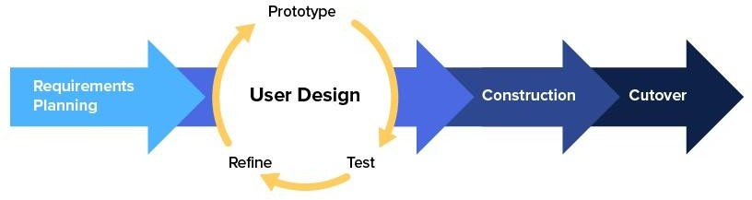

Figure 3.1 Rapid Application Development

The RAD model may be split into a total of four primary phases according to Figure

3.1. Planning for requirements, user design, construction, and cutover are the four primary phases. The prototype, test, and refine phases make up the loop that makes up the user design stage. Users engage with the prototype during this loop, which is a continuous phase, and thereafter they provide feedback. The project can then be improved by the developer using the input received. Until the actual finished product is authorized, the loop will continue. The benefit of this method is that all project criteria will be met, and users will be able to better comprehend the project's results. The needs of this project should be obvious since the time frame for utilising the RAD model project is short, and the requirement planning, as well as design phase, should not be performed for a lengthy period of time because everything has two sides.

## Phase 1: Requirement Planning

The initial step of the project should explicitly outline the needs for each of the initiatives. This is because a project's requirements could be too vague, which could lead to the project's failure. The first stage of the RAD methodology is requirement planning. The goals and objectives of this stage are to familiarize yourself with the frameworks that are already in place, to establish the procedures that the proposed application would uphold, and to have a general awareness of the challenges surrounding its development and ultimate operation.

In this step, a complete timeframe will be initialized for the project activates with the planning and preparing all the other resource needed to finish the project like cloud services accounts and development and testing devices. As well as setting up all the functional requirements and clarifying it.

## Phase 2: User Design

The user design phase serves as the foundation for developing the application. Prototype, test, and refinement are the three sub-phases that make up this phase.

The developer's job is to create the application using the requirements and specifications gathered throughout the requirement planning phase. Due to the ongoing duration of the second phase, the prototype appears to be lacking and contains defaults, mistakes, and flaws.

The developer's next duty is to test their prototype for any faults or flaws.

During the testing phase, the user's comments will also be heard to make sure the prototype meets their expectations. In order to avoid repeating the same issue in a subsequent prototype, this procedure will aid developers in considering the cause of the bugs. All errors and user comments will be noted and passed over to the following job.

The prototype must be improved after being refined. This stage of the cycle makes sure that flaws in the subsequent prototype are corrected and rectified, lowering 43 the margin of error during manufacturing and enhancing the final product's quality.

Once the refining step is complete, the cycle—in which the prototype was created earlier—begins once more.

For the proposed application, this stage will consist of few developments cycle or iterations, each will achieve some of the functional requirements, and each will complement the previous one, as well as coming with the initial UI for the application.

## 3.2.3 Phase 3: Construction

The previous phase's prototype will be developed into a functional model during this phase. Because the majority of the mistakes and adjustments were fixed during the previous phase, the developer can build the final prototype more quickly. The coding environment, framework, and hardware components will all be set up during this stage. For this project, a smartphone with a strong internet connection will be used to implement the functional model. The final model will be evaluated to make sure it satisfies the end user’s needs after all of the app modules have been integrated. To make sure the application is prepared for deployment, unit, module, and system testing will be carried out.

During this stage, the UI for the application will be finalized and the functional requirements will all achieved. An intensive unit testing and end-to-end testing will be done to make sure that the application is meeting all the planed requirements.

## 3.2.4 Phase 4: Cutover

Cutover is the final stage of the RAD model. This stage sees the debut of the completed prototype and the completion of all project-related details such as features, functionalities, and user interface. The process of data conversion, the switch to the new system, and user training are typically completed at this point. The completed construction project will then be integrated into the environment for the actual use.

In this final phase for the application, the app will be deployed to the real time testing environment. In short, the app will be set up for production.

## Development Technology

This section will briefly explain the tools and technology required to complete this project. The section will be divided into three sub-sections, which are software(s), hardware(s) and the data required for training the system.

## Software Requirements

The main software components of the application are mentioned in this section with a brief explanation of each of them.

## React.js



3.2 React.js

React.js, commonly known as React, is an open-source JavaScript library developed by Facebook for building user interfaces, especially for single-page applications. It enables developers to create web applications that can update and render efficiently by manipulating data without needing to reload the page. The core of React lies in its component-based architecture, where UI elements are broken down into independent, reusable pieces, each managing their own state. React introduces JSX, a syntax extension that allows HTML to be written within JavaScript, offering a more seamless integration of the two. A significant feature of React is its use of a Virtual DOM, which optimizes performance by making updates in memory and then rendering only the

necessary changes to the real DOM. React's design follows a unidirectional data flow, ensuring clearer and more efficient data management within applications. Additionally, React's ecosystem extends to mobile application development through React Native, allowing for native-like app experiences using familiar React concepts. The vast community and ecosystem surrounding React provide an extensive array of tools and extensions, like Redux for state management and React Router for navigation, cementing its popularity as a flexible and efficient solution for dynamic web application development.

## Tailwind CSS



3.3 Tailwindcss

Tailwind CSS is a utility-first CSS framework designed for creating custom user interfaces with speed and efficiency. It differs from traditional CSS frameworks by providing a comprehensive suite of low-level utility classes instead of predefined components. This approach allows developers to apply styles directly within HTML, such as padding, margin, and text color, significantly reducing the need for custom CSS and expediting the development process. Tailwind is renowned for its responsiveness, offering variants for different screen sizes, making responsive design more straightforward. A standout feature of Tailwind is its high customizability; developers can tailor their design system within the framework, setting their colors, fonts, and breakpoints. Additionally, Tailwind integrates seamlessly with Purge CSS, which helps in optimizing the final build by removing unused CSS, thus reducing file sizes. Its extensible nature is further enhanced by a plugin system that allows the addition of new utilities or components. The framework is supported by a growing community, with numerous third-party plugins and resources available, making it a

popular choice for developers looking for a more hands-on and controlled approach to styling web applications and crafting unique, maintainable designs.

## Open AI API

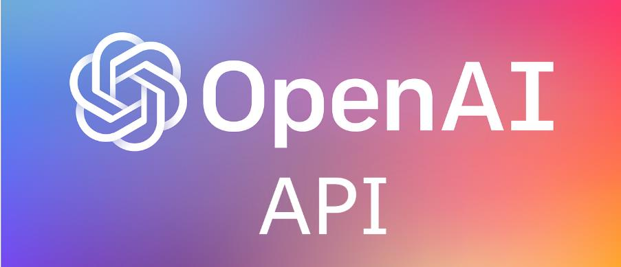

3.4 OpenAI API

The OpenAI API, a groundbreaking development by OpenAI, offers access to some of the most advanced artificial intelligence models, including the notable Generative Pretrained Transformer (GPT) series, with GPT-4 being a prominent example. This API is crafted to empower developers and businesses to incorporate innovative AI capabilities into their applications, enhancing functionalities like natural language processing, text generation, conversation, summarization, and translation. Its design emphasizes customizability and flexibility, allowing users to fine-tune the AI's responses to fit various styles, tones, and content specifications. The API's integration- friendly nature ensures that it can be seamlessly adopted into existing systems, paving the way for a wide array of applications ranging from sophisticated chatbots and virtual assistants to innovative content creation and analysis tools. Notably, the API is built` to handle varying scales of demand, making it suitable for both individual projects and extensive enterprise requirements. OpenAI is committed to continual improvement, regularly updating the API with the latest AI advancements and research. Additionally, the organization prioritizes ethical AI usage, enforcing safety guidelines and monitoring to prevent misuse, thereby underlining the importance of responsible AI deployment. The OpenAI API has rapidly gained traction across various sectors, including education, customer service, and entertainment, showcasing its versatility and the growing reliance on AI-driven solutions in the modern technological landscape.

## 3.3.1.4 Vite.js



3.5 Vite.js

Vite.js, often simply referred to as Vite, is a modern front-end build tool that has revolutionized the development experience for web projects. Developed by Evan You, the creator of Vue.js, Vite stands out primarily for its incredible speed and efficiency. This is largely due to its use of native ECMAScript modules (ESM) which enables it to serve code during development, leading to remarkably fast server starts and hot module replacement (HMR). One of Vite's most notable features is its quick cold start, as it eliminates the need for bundling during development, significantly reducing the initial server start time. Alongside this, its instant hot module replacement feature ensures that any changes in the source code are immediately visible in the browser, greatly enhancing developer productivity. Vite comes with built-in support for modern languages like TypeScript and JSX, allowing developers to use these without cumbersome additional setups. Its rich plugin ecosystem, compatible with Rollup plugins, offers a vast range of functionalities for extended development needs. For production builds, Vite utilizes Rollup under the hood, ensuring efficient and optimized final bundles. Despite being created by the founder of Vue.js, Vite is designed to be framework-agnostic, supporting a variety of frameworks including React, Svelte, and Vue. Additionally, it handles CSS imports, pre-processors, CSS Modules, and asset files like images and fonts, simplifying the overall development workflow. Vite's approach to web development, focusing on speed and modern tooling, has quickly made it a favourite in the web development community, marking a

significant shift towards more efficient and streamlined web application development processes.

## Hardware

* + - 1. **Development**

Table 3.1 Hardware specification

|  |  |
| --- | --- |
| Model | ASUS TUF Gaming |
| Processor | AMD Ryzen 7 3750H |
| Graphics Processing Unit (GPU) | Nvidia GTX |
| Operating System | Windows 11 |

## Testing

Chrome browser on a laptop and mobile phone will be used for the purpose of testing for this application as mentioned before that the application’s target is web browsers for instance the testing devices is going to be Asus laptop and iPhone 13.

# CHAPTER 4

**IMPLEMENTATION OF DESIGN**

## Introduction

The goal of this chapter is to introduce the preliminary system design and implementation. To facilitate comprehension, all functional and non-functional system requirements will be spelt out in writing. The use case diagram will be used to describe the interaction between the actor and the system to provide a more detailed description of the functional needs. In this chapter, the non-functional needs will also be discussed. The sequence diagram will also be included in this chapter to highlight the framework's basic evolution and how it tries to handle end-user problems. The system's UI will also be covered in this chapter.

## Project Timeline

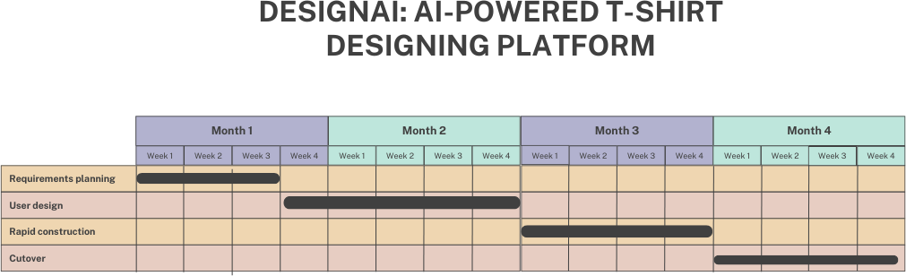

## User Requirements

The Design AI application aims to provide service as an assistant for designers in process of designing t-shirts. Therefore, in this section, the functional and non- functional requirements of the application will be discussed and explained in detail.

## Functional Requirement

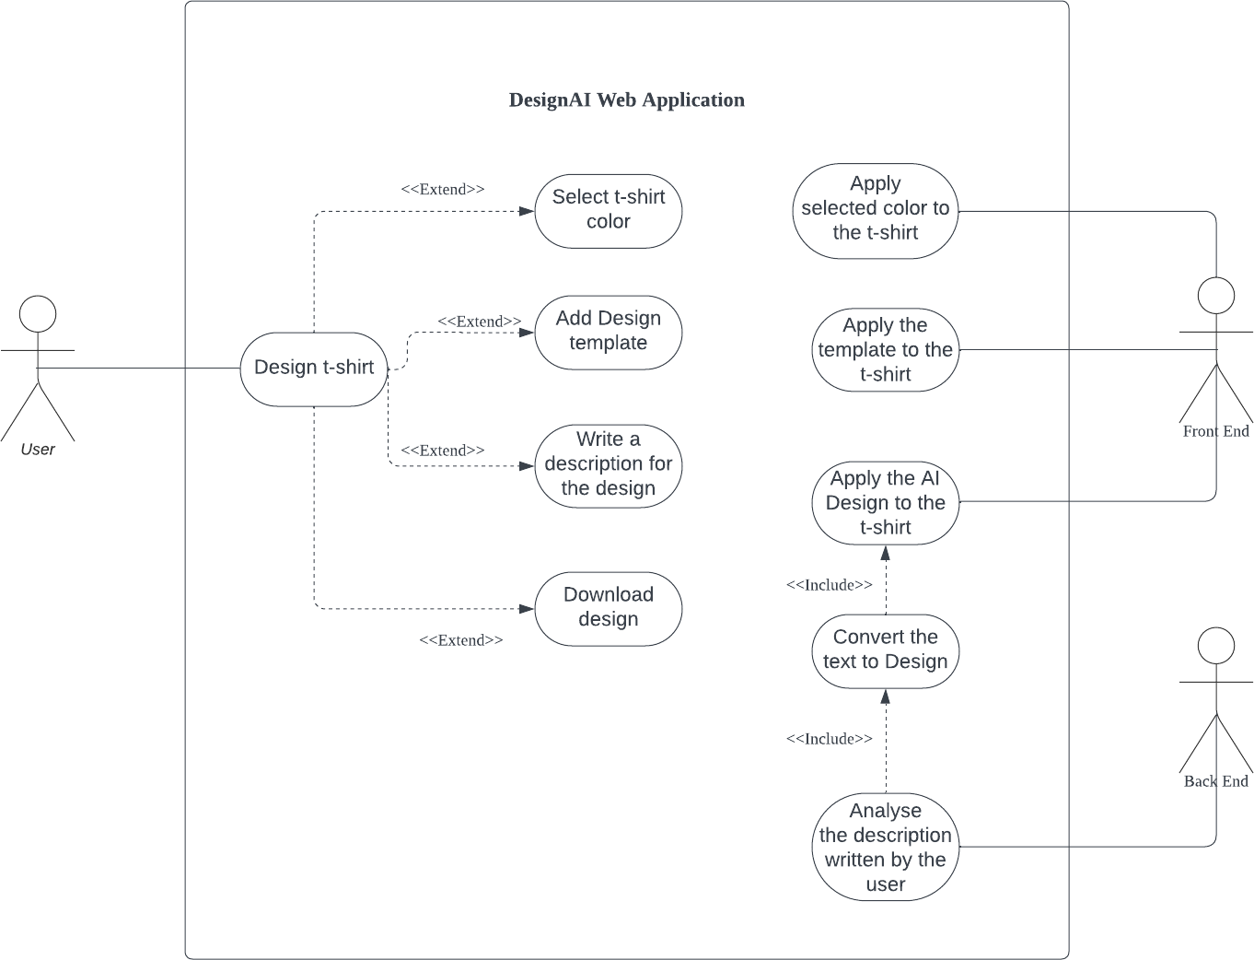

* 1. Use Case Diagram

Figure 4.1 above presents the use case diagram, which consists of the key features and main functional requirements of the application and aims to address the problems of the target users. As demonstrated by the diagram, there are three actors in the project: user which will be the designer, the front-end of the application which makes the connection between the end user and the back-end of the application, and finally the application back-end where the processing of the data will occur. The functional requirements that are available for the user are:

* + - 1. The system shall provide a feature for user to design a t-shirt.
      2. The system shall allow user to select a color for their t-shirt.
      3. The system shall allow user to upload templates that they can add to their t- shirt.
      4. The system shall allow user to write a description for a custom design.
      5. The system shall enable user to download their custom t-shirt design.
      6. The system shall allow user to download their designs in a high-quality format.
      7. The system shall apply the selected color to the t-shirt in real-time for preview.
      8. The system shall apply the chosen design template to the t-shirt and update the preview accordingly.
      9. The system shall render a visual representation of the t-shirt based on the AI interpretation of the user's written description.

## Non-functional Requirement

Non-functional system requirements can be categorised as the way a system behaves when doing certain tasks or as the system's overall quality. Non-functional requirements play a big role in framework or application development since they affect the framework's outcome through the application's response time and display standards. In this project, the following non-functional needs must be taken into account:

* + - 1. Performance: The application should load and respond swiftly, with minimal delay in design rendering and AI interaction.
      2. Usability: User-friendly interface with intuitive navigation and clear instructions.
      3. Reliability: High system reliability with minimal downtime, ensuring continuous availability for users to design and customize their T-shirts.

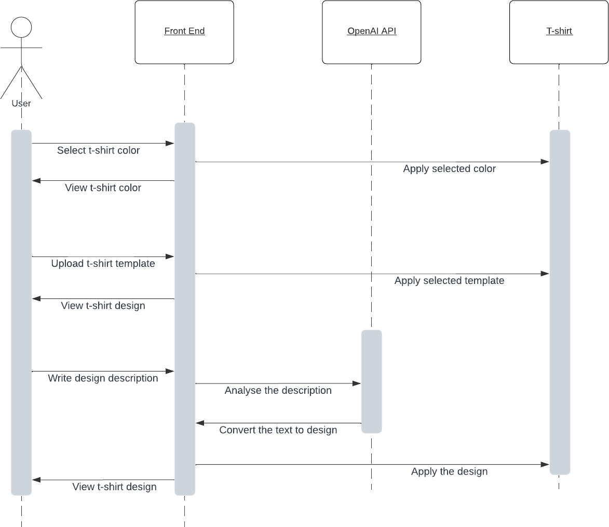

* 1. Sequence Diagram

Figure 4.2 above represents the sequence diagram of this application, The sequence diagram outlines the steps involved in customizing a t-shirt through a user interface, leveraging the OpenAI API for design generation, and eventually applying the customization to a t-shirt. Initially, the user engages with the front-end of the application, where they select their desired t-shirt color, which the system then displays for confirmation. Following this, the user uploads a t-shirt template, which is also rendered on the screen for review. The next step involves the user writing a textual description of the t-shirt design they have in mind.

The proposed application UI will be demonstrated and presented in this section of the report. It is possible that the suggested user interface will change as the project progresses. The UI's pages are listed below

## Main Page

User will face this page when he accesses the web application.

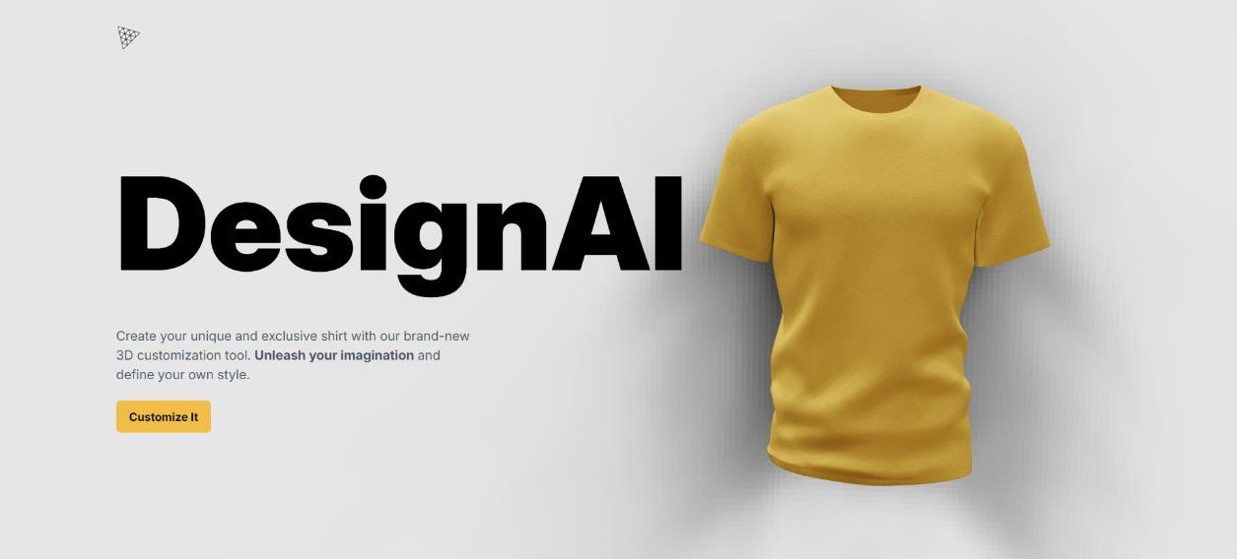

4.3 Main Page

## Designing page

This is the design page which the user will design his t-shirt in it.

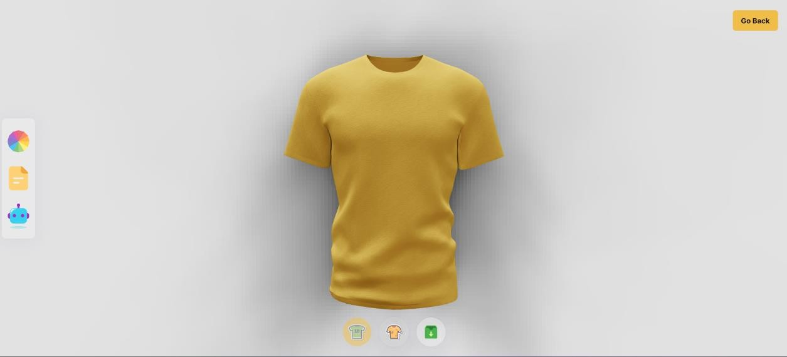

* 1. Designing page

User can select his t-shirt color from this functionality.

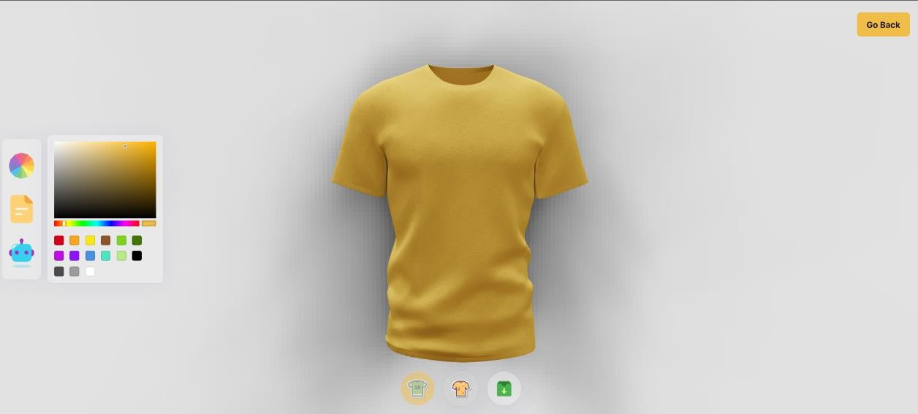

* 1. Color selection feature

## Template upload feature

User can upload a t-shirt template using this functionality.

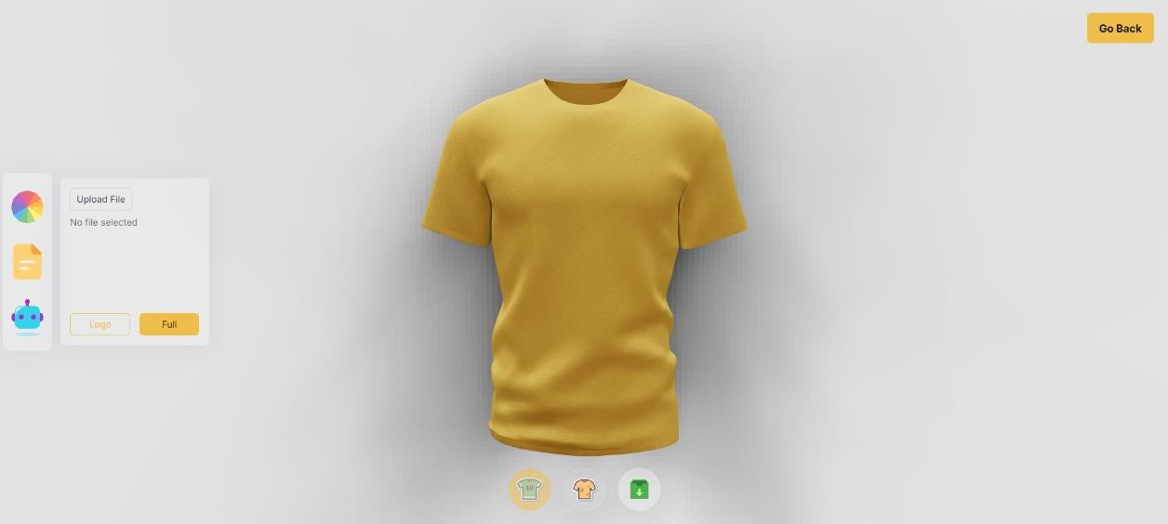

* 1. Template upload feature

## Ask AI feature

User can write his design idea here and AI will convert it to a design.

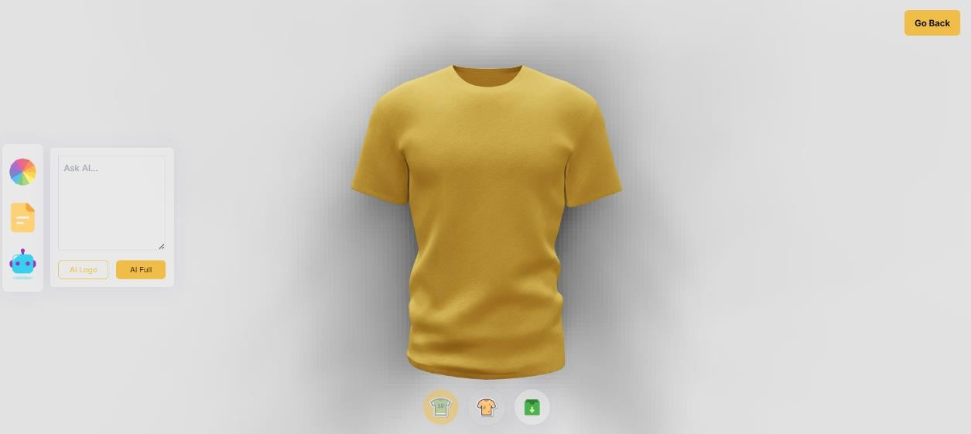

* 1. Ask AI feature

## Application testing

* + 1. **Color Selection functionality.**

|  |  |  |  |  |
| --- | --- | --- | --- | --- |
| **Test**  **Scenario ID** | CS01 | **Test Case ID** | TC-CS01 | |
| **Test Case Description** | Verify that the user can select and apply different colors to the  T-shirt design. | **Test Priority** | High | |
| Test Execution Steps: | | | | |
| **Action** | **Inputs** | **Expected Output** | **Actual**  **Output** | **Result** |
| User selects a color from  the color  palette. | Color selection (e.g., red, blue,  green). | The T-shirt preview updates to display the selected color. | Colored T- Shirt | Pass |

4.1

|  |  |  |  |  |
| --- | --- | --- | --- | --- |
| **Test**  **Scenario ID** | TU01 | **Test Case ID** | TC-TU01 | |
| **Test Case Description** | Verify that the user can upload a template and apply it to the  T-shirt design. | **Test Priority** | High | |
| Test Execution Steps: | | | | |
| **Action** | **Inputs** | **Expected Output** | **Actual**  **Output** | **Result** |
| User uploads a template file. | Template file (e.g., PNG, JPG). | The T-shirt preview updates to display the uploaded  template. | Template displayed | Pass |

4.2

|  |  |  |  |  |
| --- | --- | --- | --- | --- |
| **Test**  **Scenario ID** | AI01 | **Test Case ID** | TC-AI01 | |
| **Test Case Description** | erify that the AI generates a design based on the user’s textual  description. | **Test Priority** | High | |
| Test Execution Steps: | | | | |
| **Action** | **Inputs** | **Expected Output** | **Actual**  **Output** | **Result** |
| User inputs a design description. | Text description (e.g., “floral  pattern with  blue background”). | The AI generates and displays the design based on the description. | The AI generated and displayed the design | Pass |

4.3

|  |  |  |  |  |
| --- | --- | --- | --- | --- |
| **Test**  **Scenario ID** | DT01 | **Test Case ID** | TC-DT01 | |
| **Test Case Description** | Verify that the user can toggle between the  applied full design and the actual T-shirt  templte. | **Test Priority** | Medium | |
| Test Execution Steps: | | | | |
| **Action** | **Inputs** | **Expected Output** | **Actual**  **Output** | **Result** |
| User toggles between design views. | Switch between front and back  views | The T-shirt preview updates to show the selected view | Design toggled | Pass |

4.4

|  |  |  |  |  |
| --- | --- | --- | --- | --- |
| **Test**  **Scenario ID** | DT02 | **Test Case ID** | TC-DT02 | |
| **Test Case Description** | Verify that the user can toggle between the applied logo and the actual T-shirt  templte. | **Test Priority** | Medium | |
| Test Execution Steps: | | | | |
| **Action** | **Inputs** | **Expected Output** | **Actual**  **Output** | **Result** |
| User toggles between design views. | Switch between front and back  views | The T-shirt preview updates to show the selected view | Design toggled | Pass |

4.5

## 4.6.5 Template Download functionality.

|  |  |  |  |  |
| --- | --- | --- | --- | --- |
| **Test**  **Scenario ID** | TD01 | **Test Case ID** | TC-TD01 | |
| **Test Case Description** | Verify that the user can download the designed T- shirt in a high- quality  format. | **Test Priority** | Medium | |
| Test Execution Steps: | | | | |
| **Action** | **Inputs** | **Expected Output** | **Actual**  **Output** | **Result** |
| User  downloads the design. | Download action | The design is  downloaded in a high-quality format | Template downloaded | Pass |

4.6

# CHAPTER 5

## Results and Discussion

## Introduction

In this chapter, a general discussion of the project DESIGNAI: AI-Powered T-Shirt Designing Platform will be carried out. An overview of the application functionality and usability will be made to assess the validity of the introduced solution.

In short, the proposed application DESIGNAI is an AI-powered platform designed to assist users in the T-shirt design process. This application has been introduced to address the challenges faced by both novice and professional designers, such as mastering design fundamentals and creative stagnation. By offering intelligent design support, the system aims to democratize the design process and provide users with more opportunities to focus on creative and strategic aspects of their work. The platform utilizes advanced AI algorithms for design recommendations, color optimization, and pattern generation, ensuring a user-friendly and efficient design experience. The system's core processes, including design suggestion and customization, are powered by sophisticated machine learning models and cloud services.

## Functional Assessment

Based on the unit tests presented in the previous chapter for all the pages and main functionalities of the application, we can see that the application managed to achieve all the planned objectives, which are:

* + 1. Color Selection Functionality: The system successfully allows users to select and apply different colors to the T-shirt design. Users can see their selected color reflected in real-time on the T-shirt preview, ensuring an intuitive and responsive design experience.
    2. Template Upload Functionality: Users are able to upload template files (e.g., PNG, JPG) and apply them to their T-shirt designs. The uploaded templates are displayed correctly on the T-shirt preview, providing a seamless integration of user-provided designs into the application.
    3. Ask AI Functionality: The AI-powered feature effectively generates T-shirt designs based on user-provided textual descriptions. This functionality allows users to input their design ideas in text form and see them materialize visually, bridging the gap between conceptualization and realization.
    4. Design Toggle Functionality: Users can toggle between different design views or options, such as switching between the front and back views of the T-shirt. This functionality enhances the user experience by providing a comprehensive view of their designs from multiple perspectives.
    5. Template Download Functionality: The system allows users to download their completed T-shirt designs in high-quality formats (e.g., PNG, PDF). This ensures that users receive their designs in a suitable format for printing or sharing, maintaining the quality and integrity of the designs.

The successful implementation and testing of these features demonstrate that DESIGNAI has met its objectives, offering a comprehensive and user-friendly platform for T-shirt design that caters to both novice and professional designers. The application provides a robust set of tools for creating, customizing, and finalizing T- shirt designs, thereby fulfilling its intended purpose and delivering a valuable solution to its users.

## Usability Assessment

The DESIGNAI application has demonstrated the successful integration of highly intuitive interactive interfaces. These interfaces, while rich in functionality, remain remarkably user-friendly and resonate well with users due to their straightforward design and ease of navigation.

The application prioritizes maintaining a streamlined design, confining itself to essential pages and features, thereby reducing potential user overwhelm and ensuring an optimal user experience. Key usability aspects include:

Simplistic and Intuitive Design: The user interface is designed to be clean and minimalistic, allowing users to focus on the task of designing without unnecessary distractions. The use of clear icons, straightforward menus, and logical layout enhances the overall user experience.

Responsive Interaction: The application offers real-time updates and feedback. For example, when users select a color or upload a template, the changes are immediately reflected in the T-shirt preview. This responsiveness helps in maintaining user engagement and satisfaction.

User-Friendly Features: Features such as the color selection palette, template upload, and AI-powered design suggestions are designed to be easily accessible and simple to use, even for users with minimal technical skills. The "Ask AI" feature, in particular, provides a seamless bridge between user input and visual design output, enhancing usability.

Efficient Navigation: The application structure is designed to minimize the number of steps needed to complete a task. Users can easily navigate between different functionalities like color selection, template upload, and design preview without getting lost or confused.

Help and Support: The application includes helpful tooltips and guides that assist users in understanding how to use various features. This support ensures that even new users can quickly become proficient in using the application.

The delicate balance between usability and design functionality underscores DESIGNAI's commitment to efficiency and user-centered design principles. By focusing on simplicity, responsiveness, and user-friendly features, the application ensures a positive user experience that meets the needs of both novice and professional designers.

## Summary

The results of the DESIGNAI: AI-Powered T-Shirt Designing Platform project are thoroughly explored in this chapter. Fundamentally, DESIGNAI is an innovative platform that assists users in the T-shirt design process by leveraging advanced AI algorithms. The application addresses a range of challenges faced by designers, enabling them to focus on creativity while the system handles complex design tasks such as color selection, template integration, and AI-generated design suggestions.

Based on the unit tests from the previous chapter, a comprehensive functionality evaluation was conducted. The outcomes show that the application accomplished all of its goals, including:

* Color Selection Functionality: Users can select and apply different colors to the T-shirt design, with real-time updates displayed on the preview.
* Template Upload Functionality: Users can upload and integrate custom templates into their designs seamlessly.
* Ask AI Functionality: The AI effectively generates designs based on user- provided textual descriptions, bridging the gap between conceptual ideas and visual outputs.
* Design Toggle Functionality: Users can easily toggle between different design views or options.
* Template Download Functionality: Users can download their finalized T-shirt designs in high-quality formats suitable for printing or sharing.

DESIGNAI stands out from a usability perspective because of its highly intuitive interfaces, which are user-friendly and designed to minimize complexity. The application’s design ensures that users, regardless of their technical skill level, can easily navigate and utilize the platform's features. The emphasis on simplicity, responsiveness, and user support helps reduce the possibility of user overwhelm while adhering to user-centered design principles.

The success of the application is based on the synthesis of usability, effectiveness, and minimalist design. DESIGNAI not only meets its functional objectives but also excels in providing a satisfying user experience, making it a valuable tool for both novice and professional T-shirt designers.

# CHAPTER 6

# CONCLUSION AND RECOMMENDATION

## Project Summary

The DESIGNAI: AI-Powered T-Shirt Designing Platform is designed to provide users with a comprehensive and intuitive tool for creating and customizing T-shirt designs. Its main goal is to simplify and enhance the T-shirt design process for both novice and professional designers. By leveraging advanced AI algorithms, DESIGNAI facilitates various design tasks such as color selection, template integration, and generating designs based on textual descriptions.

The platform aims to make the T-shirt design process more efficient, user-friendly, and accessible. DESIGNAI offers a range of features to elevate the design experience, ensuring users can create high-quality, personalized T-shirt designs with ease. As a result, this application provides cutting-edge design capabilities and technology, which is highly beneficial to designers, small business owners, and anyone interested in creating custom apparel.

## Achievement

The main objective of this project is to design an AI-powered platform specifically for T-shirt design, targeting both novice and professional designers. The DESIGNAI application offers a user-friendly interface and can be utilized by individuals and businesses aiming to create custom T-shirt designs.

To ensure that the final product meets user demands, the initial challenges and specific user requirements were prioritized during development. The user interface is intentionally designed to be straightforward, ensuring a low learning curve to enable

users to quickly navigate and utilize the system. The application's design focuses on key elements, namely color selection, template integration, and AI-generated design suggestions.

The application was subjected to a series of tests to ensure that all requirements were met before moving on to the User Acceptance Testing (UAT) phase. After thorough testing and review, the UAT phase was launched with volunteers from the target user base. Feedback from these users made it clear that the application was well-received and effectively met their design needs, with no significant obstacles encountered.

DESIGNAI successfully achieved its primary goals by:

* + 1. Providing a robust platform for T-shirt design that caters to various user needs.
    2. Implementing a user-friendly interface that simplifies the design process.
    3. Utilizing advanced AI algorithms to offer intelligent design support.
    4. Ensuring high user satisfaction through rigorous testing and user feedback integration.

## Future Work

The capabilities of programs like DESIGNAI can always be improved and expanded as the technological landscape and user requirements evolve over time. The following areas will be the focus of future development and improvement moving forward:

* + 1. Enhanced AI Design Generation: Improving the sophistication and creativity of AI-generated designs will be a major focus for future revisions. While the current system provides valuable design suggestions, further optimization will ensure that users receive even more innovative and diverse design options.
    2. Expanded Customization Options: Recognizing that each user has unique design preferences and requirements, future updates will aim to offer a broader set of features for personalizing T-shirt designs. This will include more advanced editing tools, additional template options, and enhanced color palettes to cater to a wider range of user preferences.
    3. Improved User Experience: Efforts will be made to continually enhance the user interface and overall experience. This includes optimizing the responsiveness of the platform, simplifying navigation, and integrating more user support features such as tutorials and help guides.
    4. Integration with E-commerce Platforms: Future development may include integrating DESIGNAI with popular e-commerce platforms, allowing users to directly sell their custom designs. This would streamline the process from design to market, making it easier for users to monetize their creativity.
    5. Enhanced Security Measures: With increasing concerns about data privacy and the importance of protecting intellectual property, actions will be taken to further strengthen DESIGNAI's security framework. This will involve improving data encryption protocols and ensuring secure data transmission and storage methods.
    6. Support for Collaborative Design: Future updates will focus on enabling collaborative design features, allowing multiple users to work on a single design project simultaneously. This will be particularly beneficial for design teams and educational settings.
    7. Mobile Application Development: Developing a mobile version of DESIGNAI will be considered to provide users with the flexibility to design on-the-go. This will enhance accessibility and convenience for users who prefer mobile devices over desktop platforms.

By focusing on these areas, DESIGNAI aims to continuously evolve and adapt to meet the changing needs and preferences of its users, ensuring it remains a valuable and innovative tool in the T-shirt design industry.

## Summary

The DESIGNAI: AI-Powered T-Shirt Designing Platform application's future work chapter focuses on strengthening and enhancing its capabilities. Key areas for development include enhancing the sophistication of AI design generation, expanding customization options to accommodate a wider range of user preferences, and continually improving the user experience through optimized responsiveness and user support features.

Future updates will also focus on integrating DESIGNAI with e-commerce platforms to streamline the transition from design to market, strengthening security measures with an emphasis on data privacy and encryption, and introducing collaborative design features to support teamwork and educational settings. Additionally, developing a mobile application version will enhance accessibility and convenience for users who prefer designing on-the-go.

# REFERENCES

* + 1. Bergman, M., Innilä, M., Björkman, R., & Dahlqvist, J. (n.d.). *Artificial intelligence in ideation for design and product development in the fashion industry Title: Artificial intelligence in ideation for design and product development in the fashion industry*.
    2. Brown, T. B., Mann, B., Ryder, N., Subbiah, M., Kaplan, J., Dhariwal, P., Neelakantan, A., Shyam, P., Sastry, G., Askell, A., Agarwal, S., Herbert- Voss, A., Krueger, G., Henighan, T., Child, R., Ramesh, A., Ziegler, D. M., Wu, J., Winter, C., … Amodei, D. (2020). *Language Models are Few- Shot Learners*. <http://arxiv.org/abs/2005.14165>
    3. Cao, Y., Li, S., Liu, Y., Yan, Z., Dai, Y., Yu, P. S., & Sun, L. (2023). *A*

*Comprehensive Survey of AI-Generated Content (AIGC): A History of Generative AI from GAN to ChatGPT*. <http://arxiv.org/abs/2303.04226>

* + 1. Chakraborty, S., Hoque, M. S., Jeem, N. R., Biswas, M. C., Bardhan, D., & Lobaton, E. (2021). Fashion recommendation systems, models and methods: A review. In *Informatics* (Vol. 8, Issue 3). MDPI AG. https://doi.org/10.3390/informatics8030049
    2. Choi, W., Jang, S., Kim, H. Y., Lee, Y., Lee, S. goo, Lee, H., & Park, S. (2023). Developing an AI-based automated fashion design system: reflecting the work process of fashion designers. *Fashion and Textiles*,

*10*(1). https://doi.org/10.1186/s40691-023-00360-w

* + 1. Dang, D. (n.d.). *ARTIFICIAL INTELLIGENCE: AI IN FASHION AND BEAUTY E-COMMERCE*.
    2. Dennis, C. A. (n.d.). AI-Generated Fashion Designs: Who or What Owns the Goods? In *Fordham Intellectual Property, Media and Entertainment Law Fordham Intellectual Property, Media and Entertainment Law Journal Journal* (Vol. 30). https://ir.lawnet.fordham.edu/iplj/vol30/iss2/6
    3. Guo, Z., Zhu, Z., Li, Y., Cao, S., Chen, H., & Wang, G. (2023). AI

Assisted Fashion Design: A Review. *IEEE Access*, *11*, 88403–88415. https://doi.org/10.1109/ACCESS.2023.3306235

* + 1. Joon, J., & Chung, Y. (2023). *Steerable AI-powered Art-making Tools*.
    2. Liu, L., Zhang, H., Ji, Y., & Jonathan Wu, Q. M. (2019). Toward AI fashion design: An Attribute-GAN model for clothing match. *Neurocomputing*, *341*, 156–167. https://doi.org/10.1016/j.neucom.2019.03.011
    3. Shenhao, L. (n.d.). *Fashion Design Empowered by Digital Technology*.
    4. Shirkhani, S., Mokayed, H., Saini, R., & Chai, H. Y. (2023). Study of AI- Driven Fashion Recommender Systems. *SN Computer Science*, *4*(5). https://doi.org/10.1007/s42979-023-01932-9
    5. Shi Van Dyk Lewis, M. (n.d.). *Using Artificial Intelligence to Analyze Fashion Trends*. https://fashionpedia.github.io/home/index.html
    6. Zou, X., & Wong, W. (2021). *fAshIon after fashion: A Report of AI in Fashion*. <http://arxiv.org/abs/2105.03050>